34.74: In this context, the microscope just takes an image and makes it visible. The real optics are at the glass surfaces.
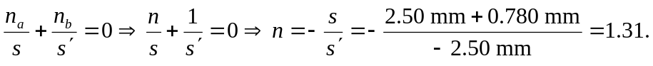
Note that the object and image are measured from the front surface of the second plate, making the image virtual.

